

**SRI LANKA INSTITUTE OF ADVANCED TECHNOLOGICAL EDUCATION**

WEB PROGRAMMING GROUP PROJECT FINAL REPORT

**Fashion E-Commerce Platform**

**WP-1024**

Department of Information Technology

Advanced Technological Institute

Kegalle

2022

1. KEG/IT/2022/F/62 - M.A.D.A. Hemachandra (Group Leader)
2. KEG/IT/2022/F/75 - P.D.M. Karunarathna
3. KEG/IT/2022/F/78 - M.M.N.I.S. Bandara
4. KEG/IT/2022/F/79 - N.N.M.I.T. Gunawardana

Submission Date – 18/11/2024

# Project Report Structure

## **Table of Contents**

**Content Page No**

Project Report Structure 2

**Table of Contents** 2

**Abstract** 3

Content Guidelines 4

**Introduction** 4

**Flow Chart** 5

**Wireframes** 6

**Design Specifications** 11

**Individual Component Details** 18

Conclusion 20

**References** 21

## **Abstract**

The Zulo E-commerce website is designed to provide a smooth and efficient online shopping experience, allowing users to browse, select, and purchase a wide variety of products. Built using PHP, HTML, CSS, and JavaScript, the project aims to create a responsive, user-friendly interface with essential e-commerce functionalities. Key features include user authentication, enabling secure login and registration; a wishlist function for saving favorite items; and an order history page that helps users track their past purchases.

The website’s development methodology involves a structured, modular approach, integrating HTML, CSS, and Bootstrap for front-end design, while PHP handles back-end processing and user session management. JavaScript adds interactivity and real-time validation on the front end. Font Awesome is used to improve UI aesthetics with icons, while Bootstrap ensures a responsive layout across devices.

In testing, Zulo demonstrated effective functionality across all primary features, providing a seamless shopping experience from product browsing to checkout. This project showcases a fully functional e-commerce model that is visually appealing and user-centric.

# Content Guidelines

## **Introduction**

Zulo is an e-commerce website built to provide a smooth, efficient, and user-friendly shopping experience. The platform allows users to explore a variety of products, add items to their cart, and complete their purchases securely. Additionally, it offers features such as user authentication, a wishlist, order history, and product search, ensuring that users can easily navigate and personalize their shopping experience.

**Objectives**: The primary objectives of this project are:

1. To create a secure, easy-to-use online shopping platform.
2. To allow users to manage their favorite items with a wishlist.
3. To enable customers to review their past purchases through an order history.
4. To ensure a responsive design that works seamlessly across different devices.

**Technologies Used**: The project is developed using:

* **PHP**: For server-side scripting and handling user sessions.
* **MySQL**: To store data such as user accounts, product details, and orders.
* **HTML & CSS**: For creating the structure and styling of the website.
* **JavaScript**: For interactive elements and improving user experience.
* **Bootstrap**: To ensure a responsive and mobile-friendly layout.
* **Font Awesome**: For icons that enhance visual appeal.

## **Flow Chart**

* **Admin Flowchart**

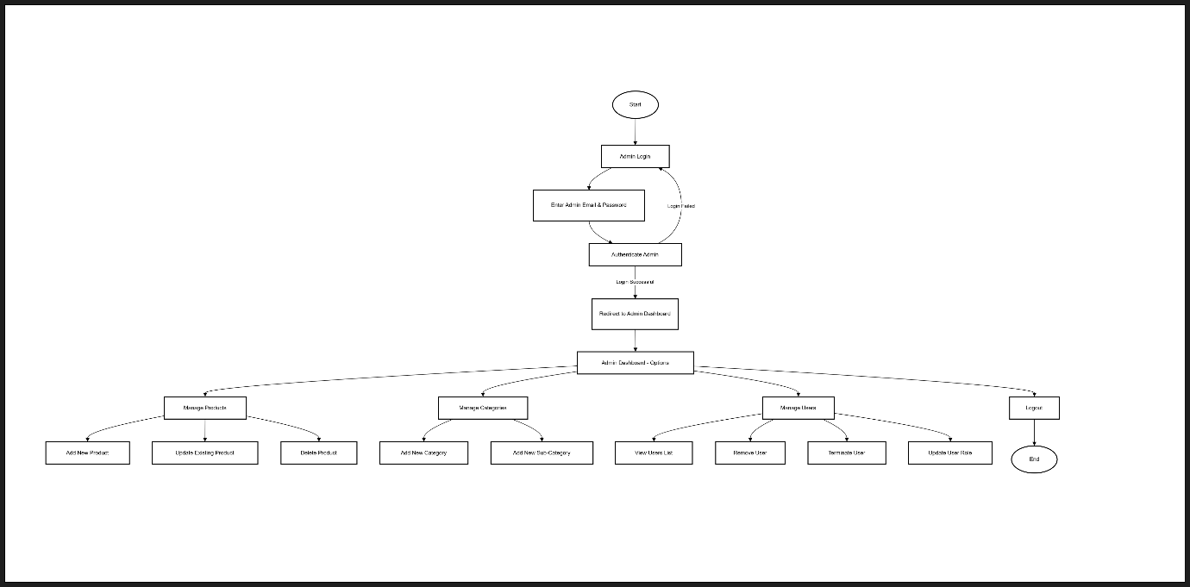

* **User Flowchart**

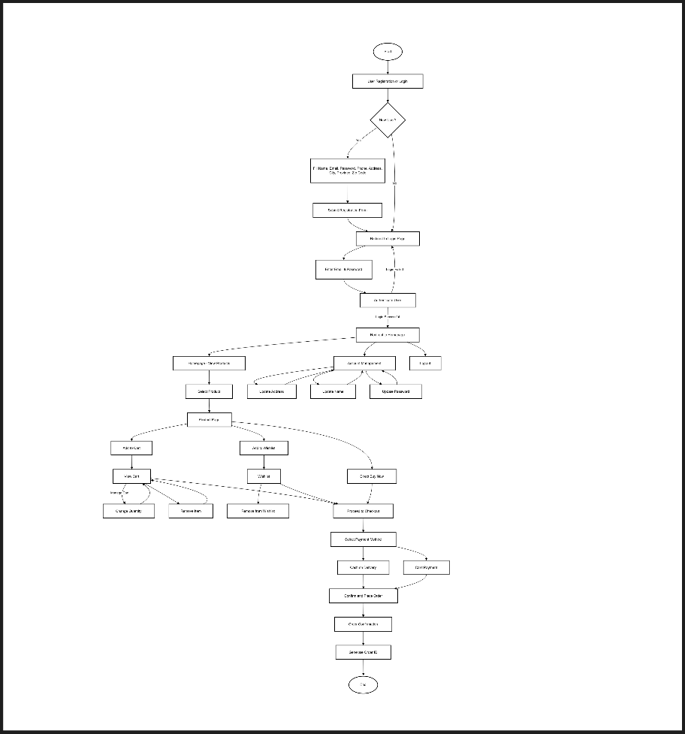

## **Wireframes**

* **Home Page**

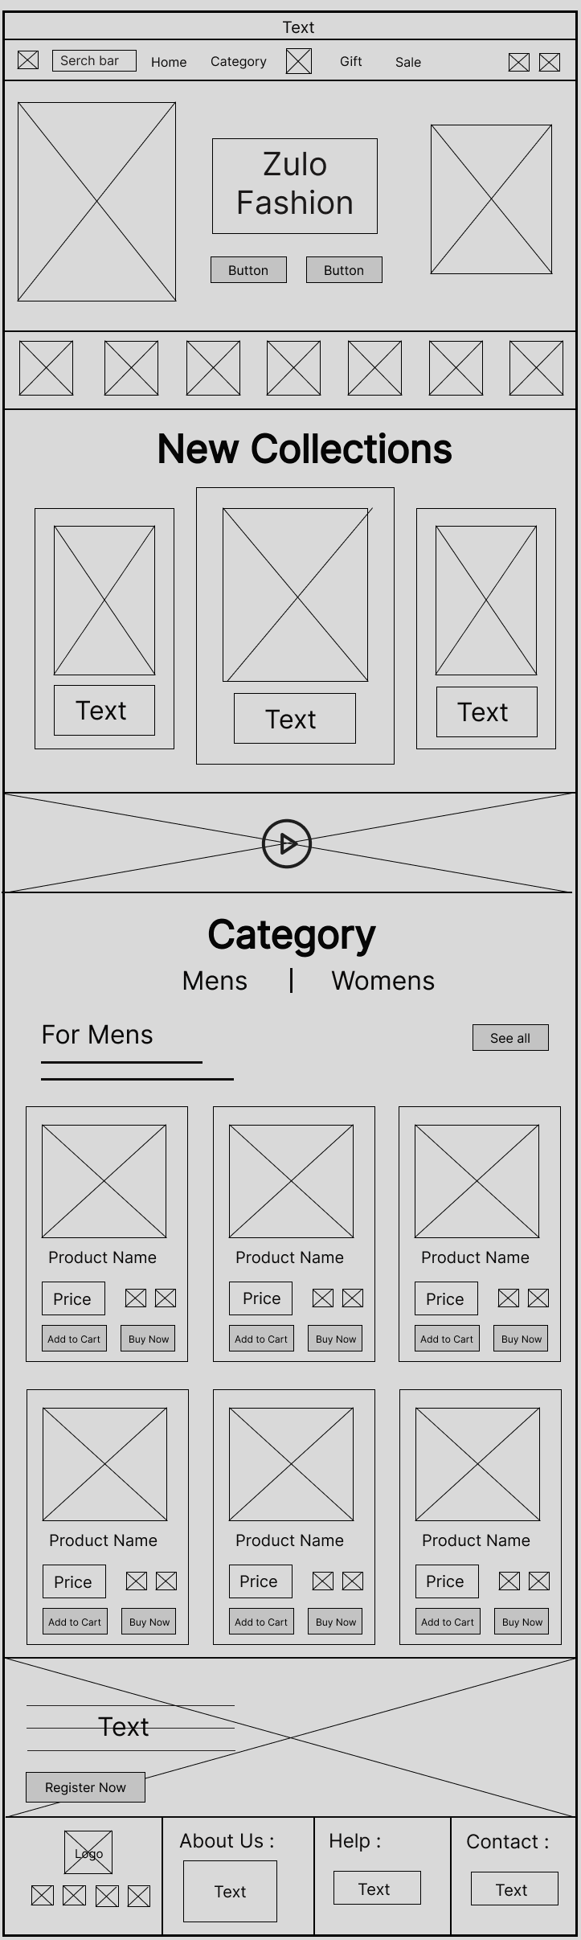

* **Login Page**

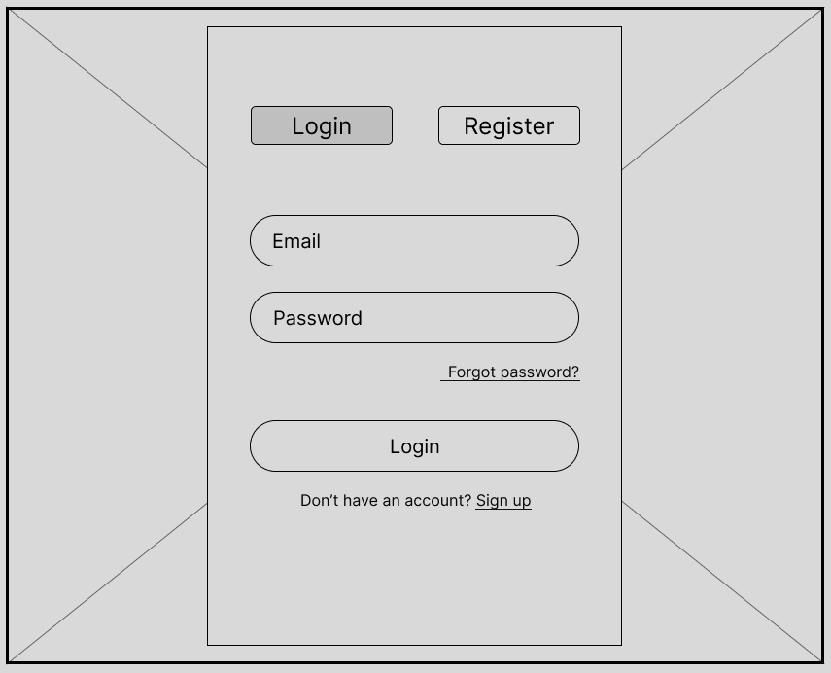

* **Register Page**

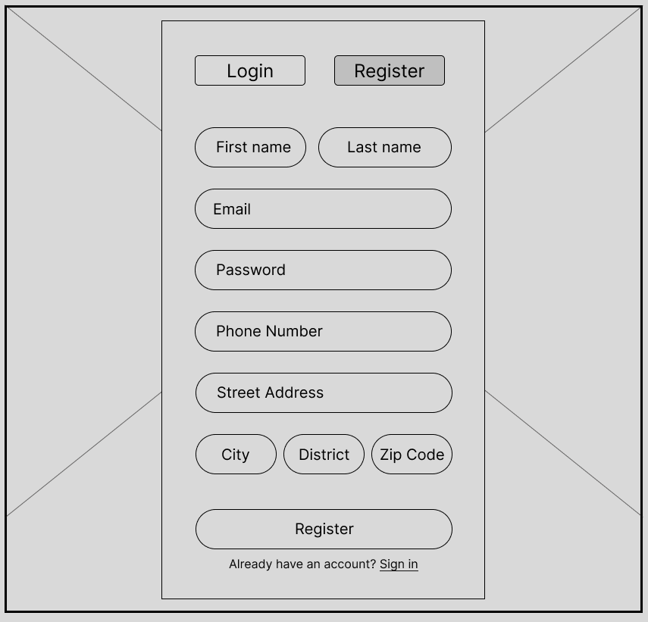

* **UserPage_OrderHistory**

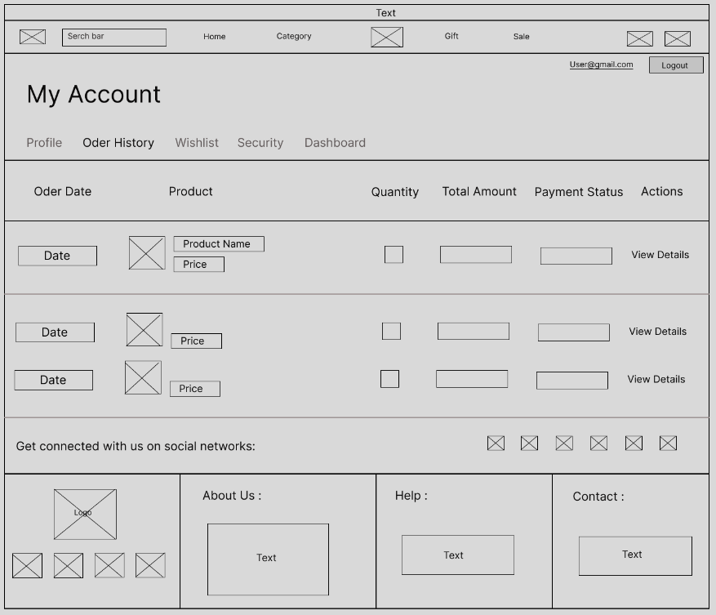

* **UserPage_Profile**

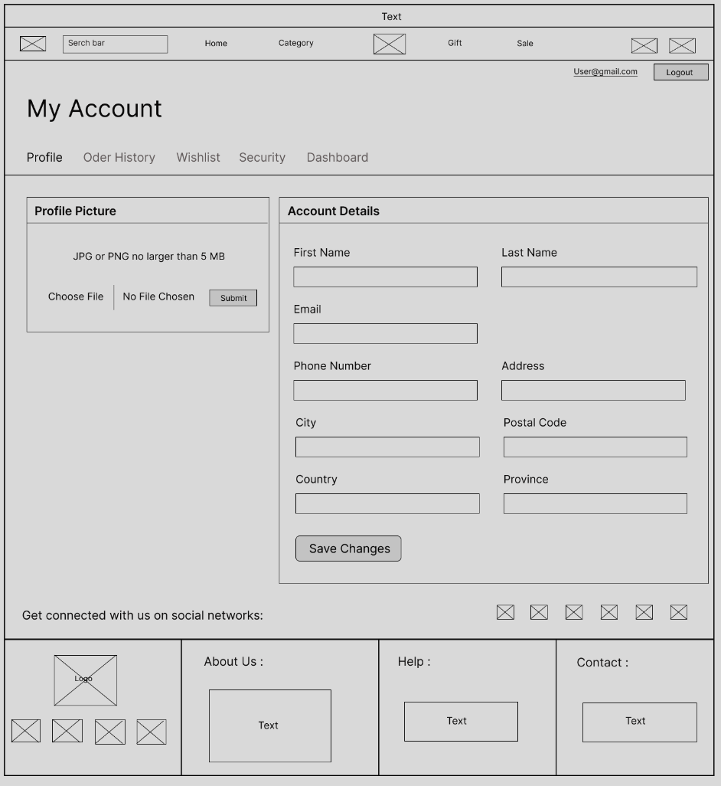

* **UserPage_Security**

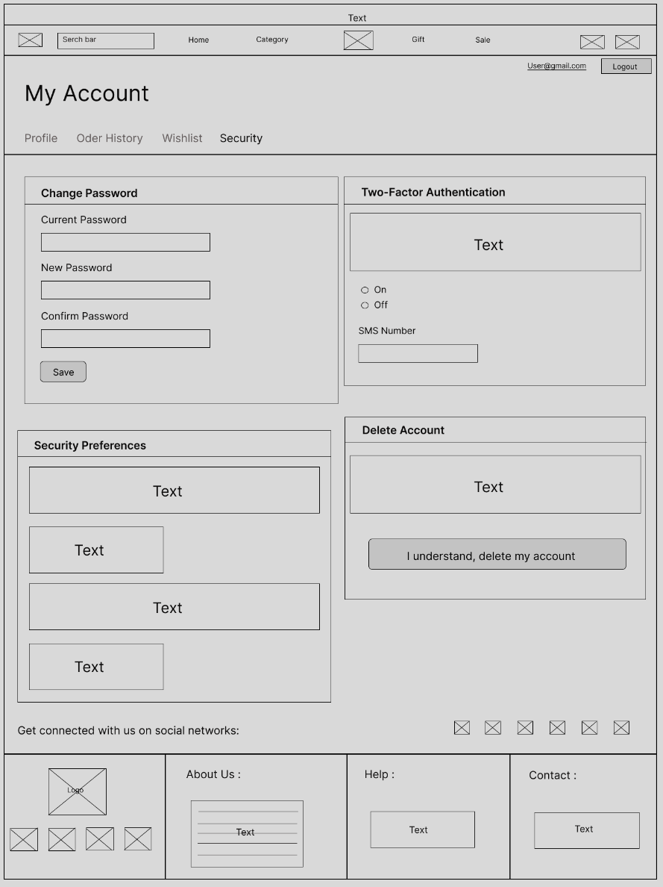

* **UserPage_Wishlist**

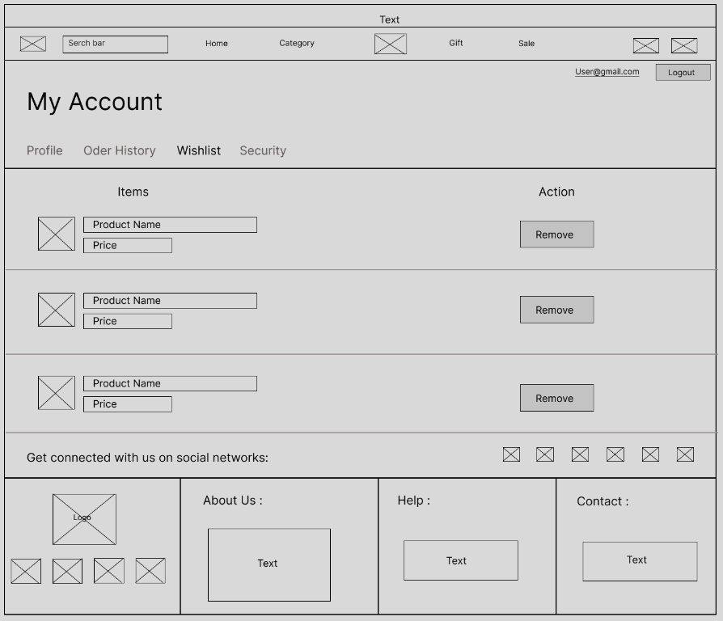

* 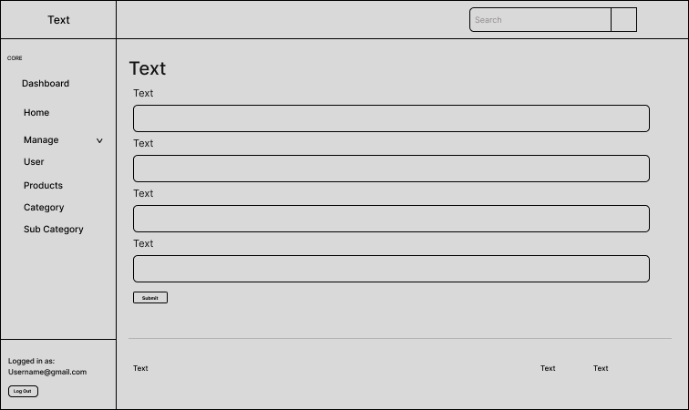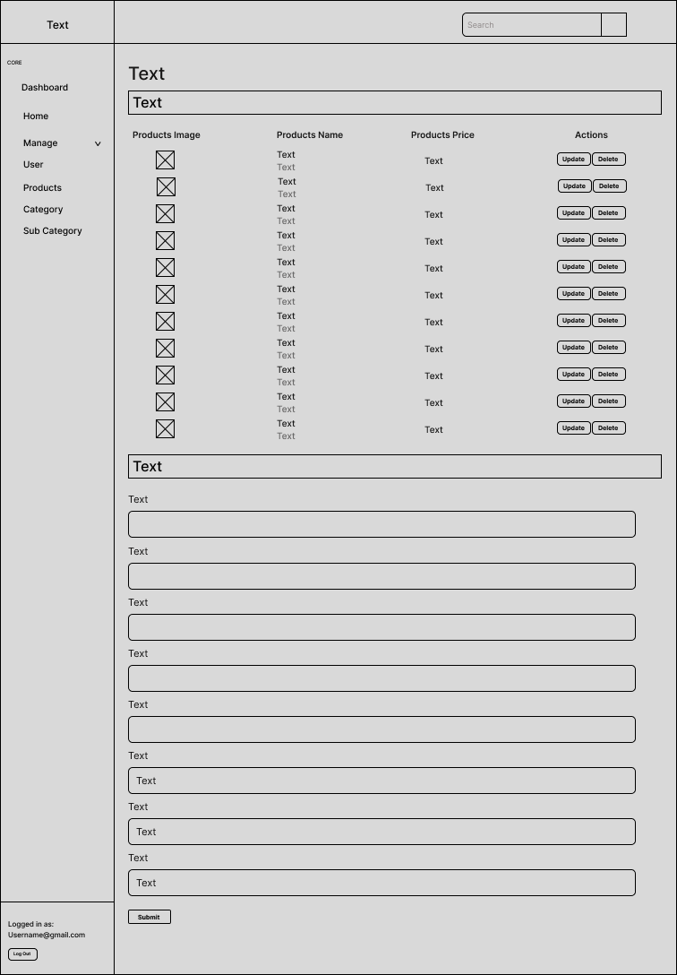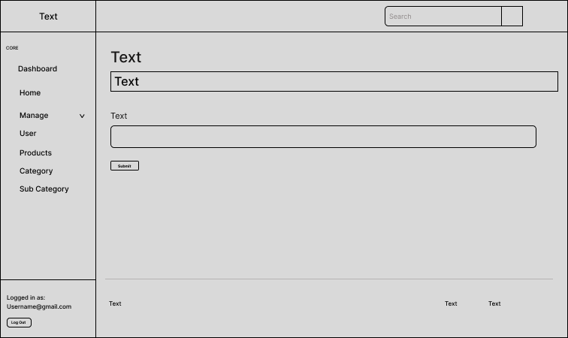**Dashboard**

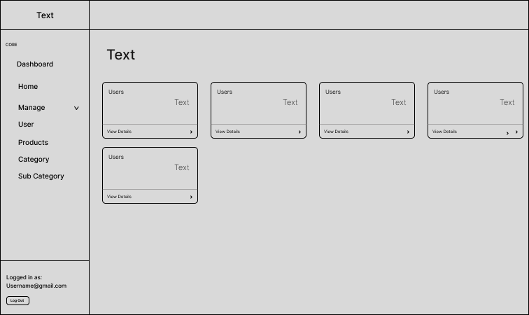

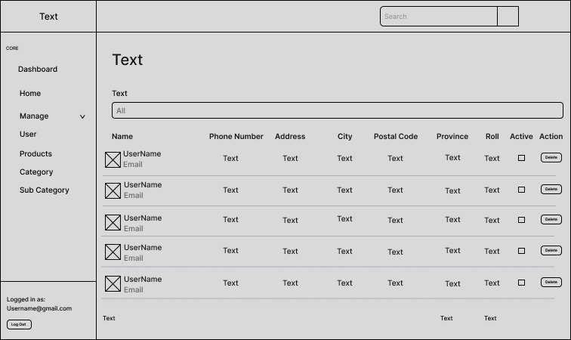

## **Design Specifications**

* 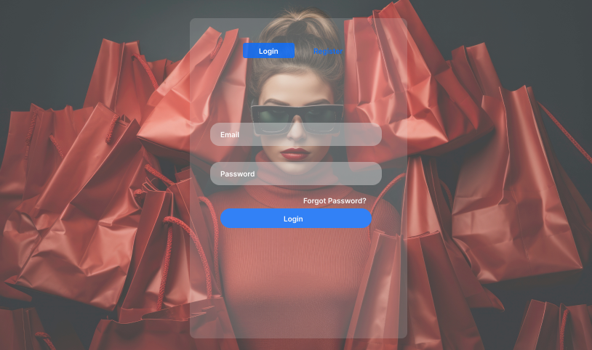**Login and Register Page**

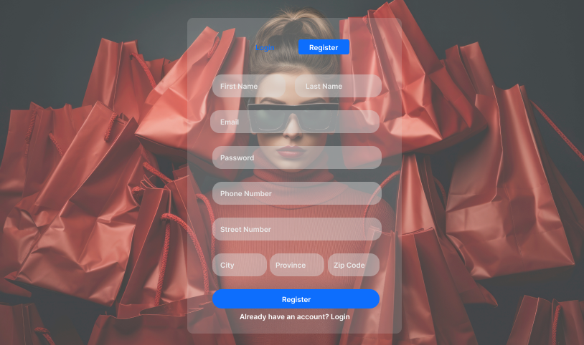

* **Home Page**

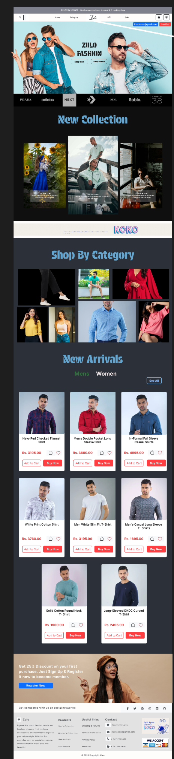

* **Men and Women Pages**

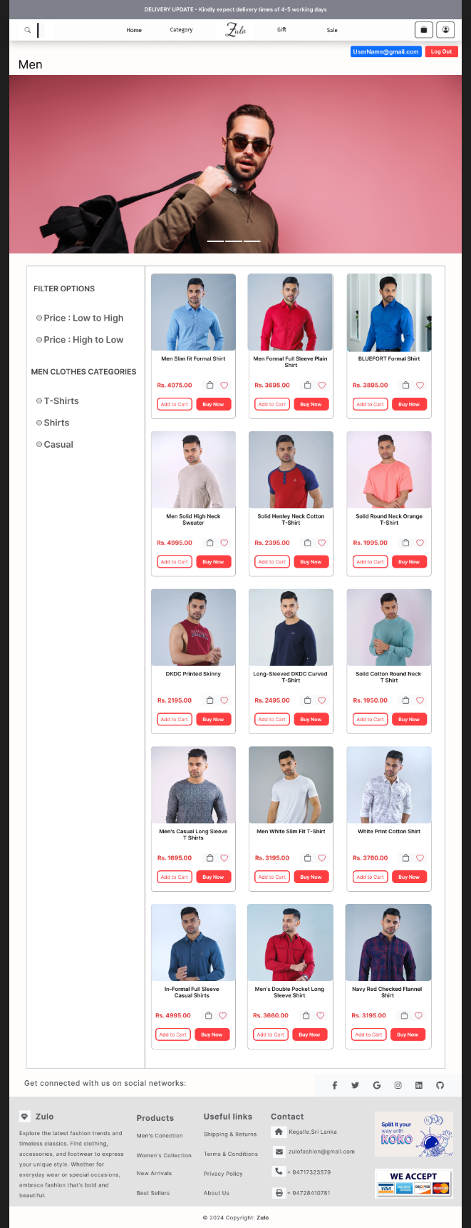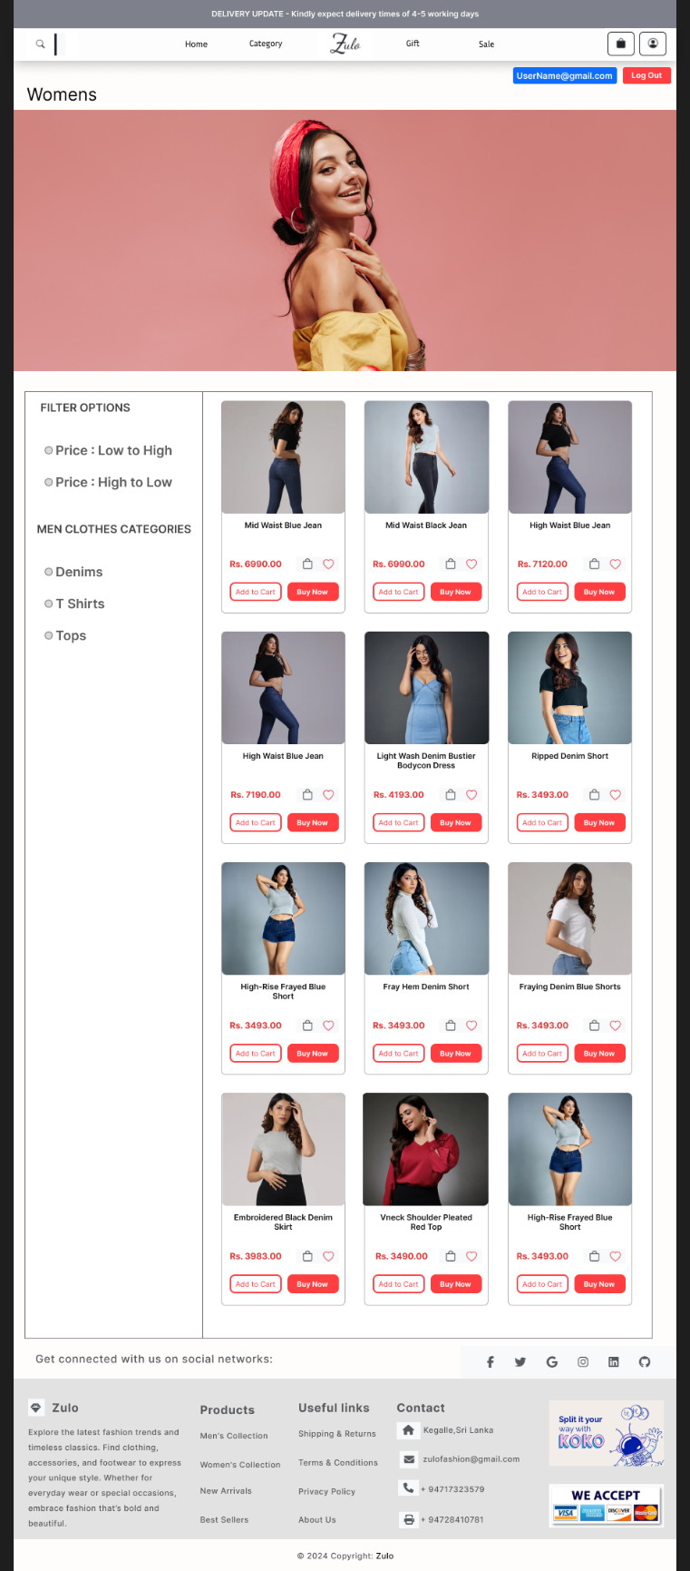

* **Cart Page**

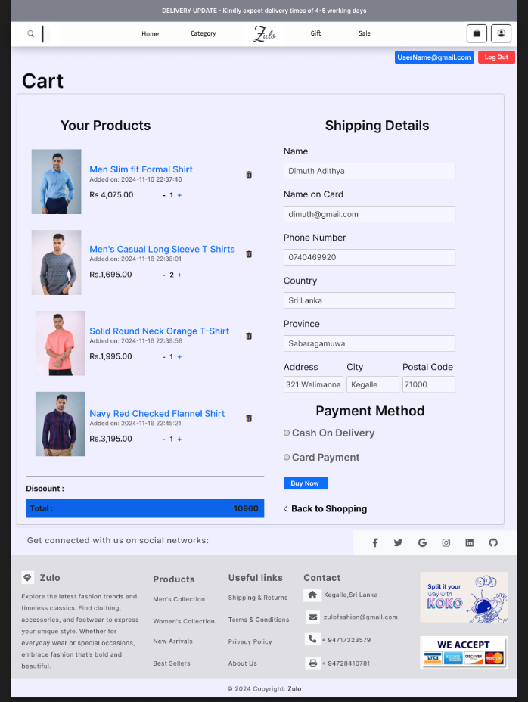

* **Product Card**

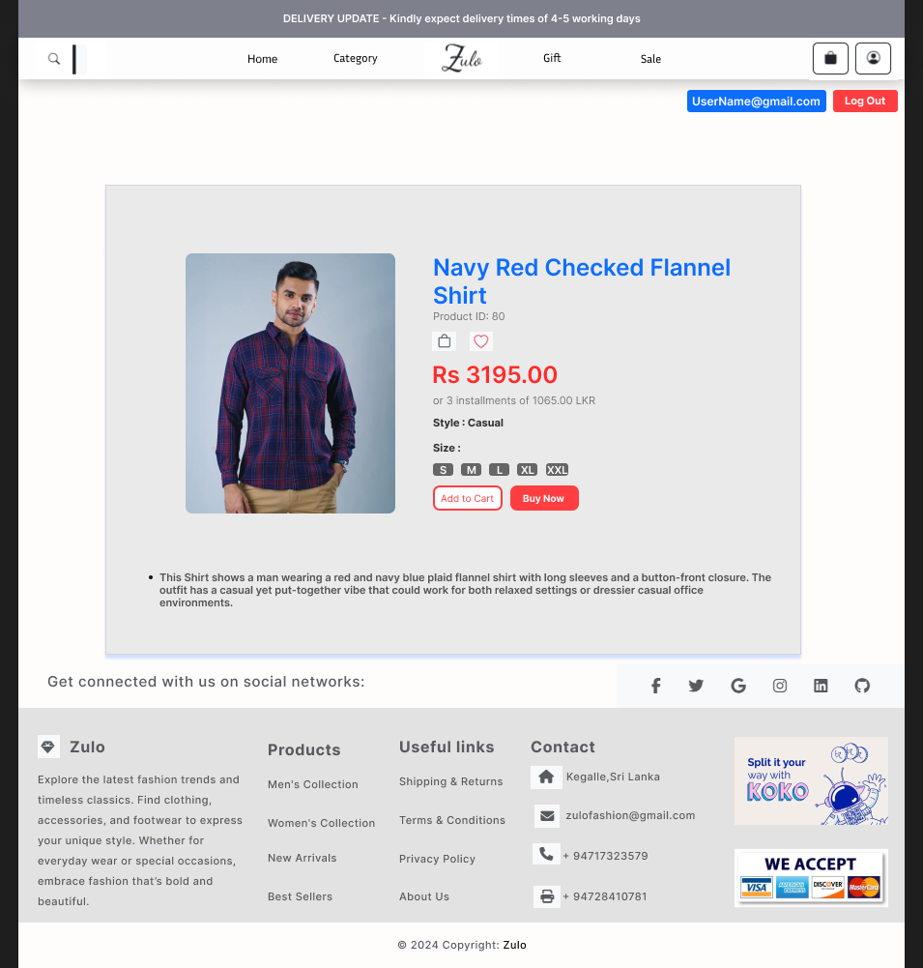

* **Account_Profile**

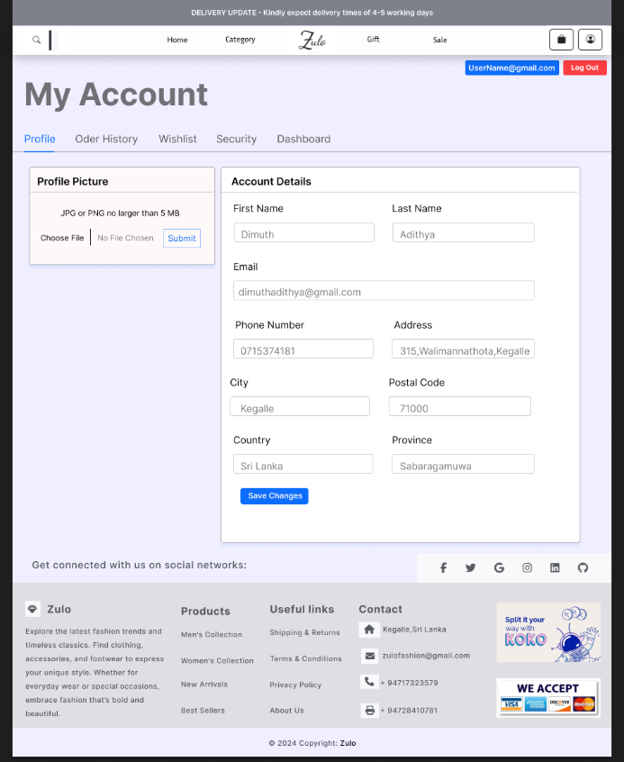

* **Account_OrderHistory**

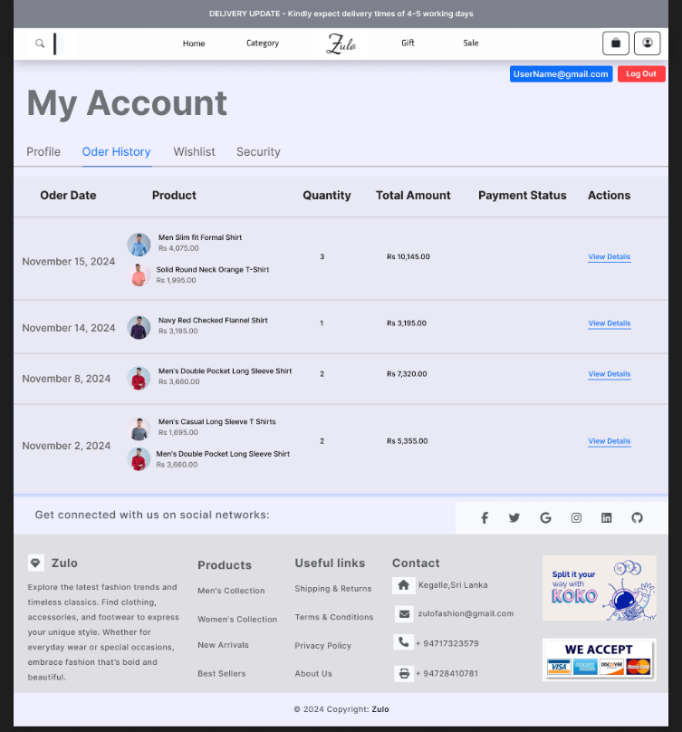

* **Acoount_Security**

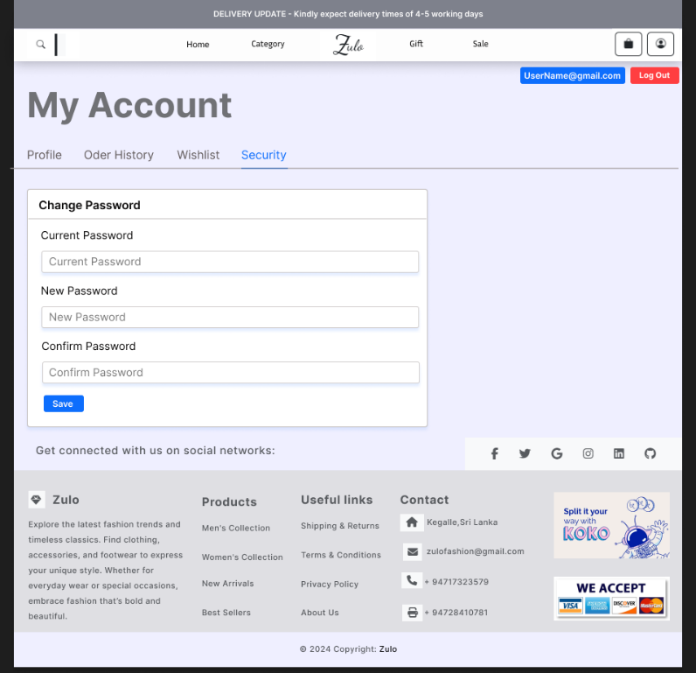

* **Account_Wishlist**

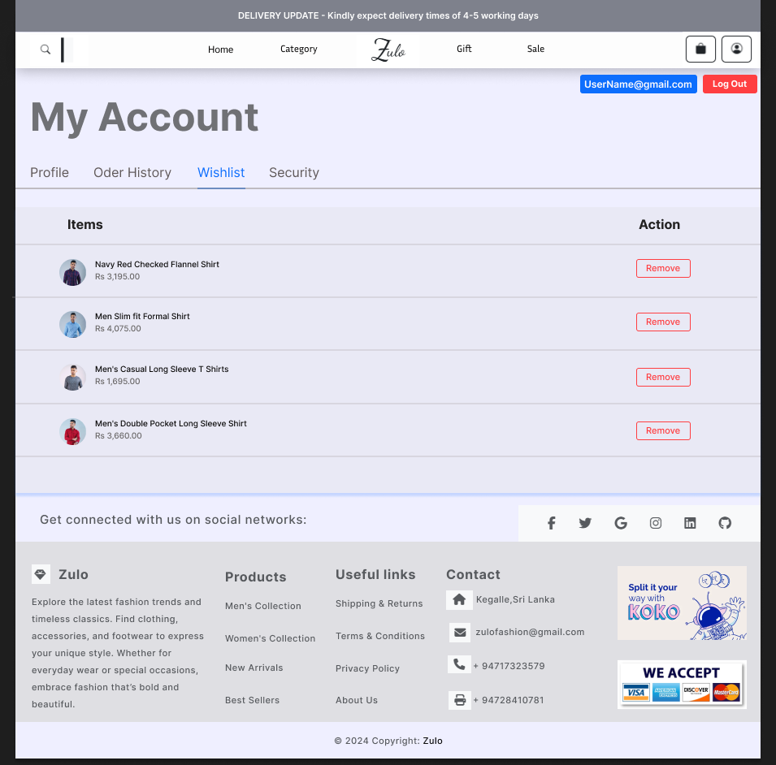

* **Dashboard**

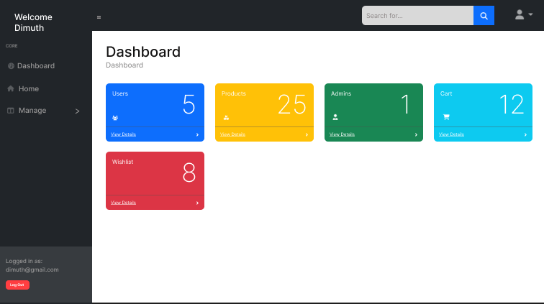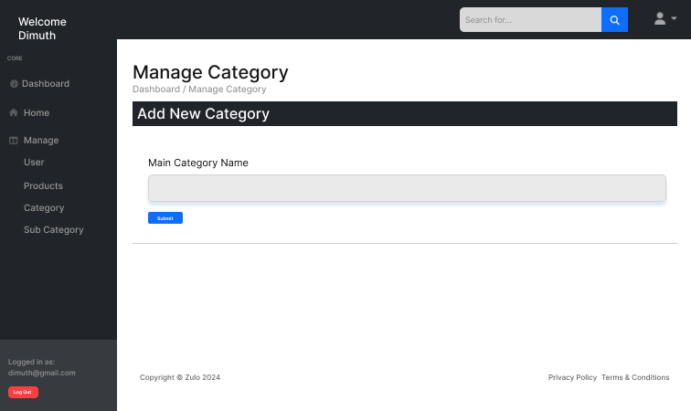

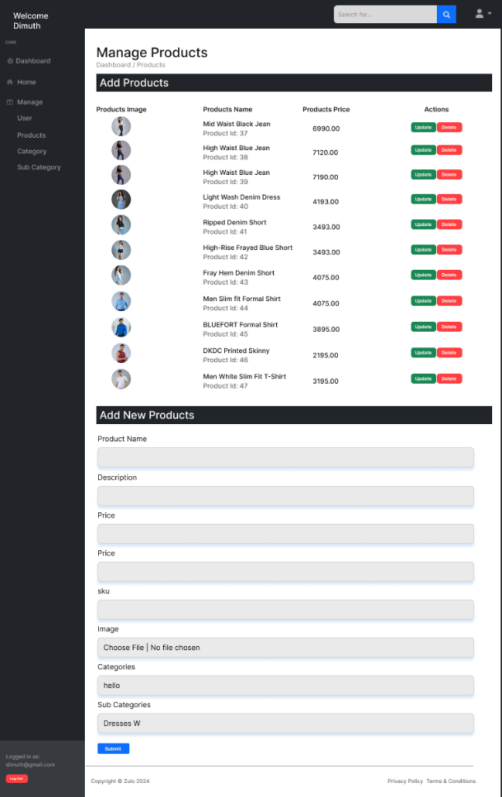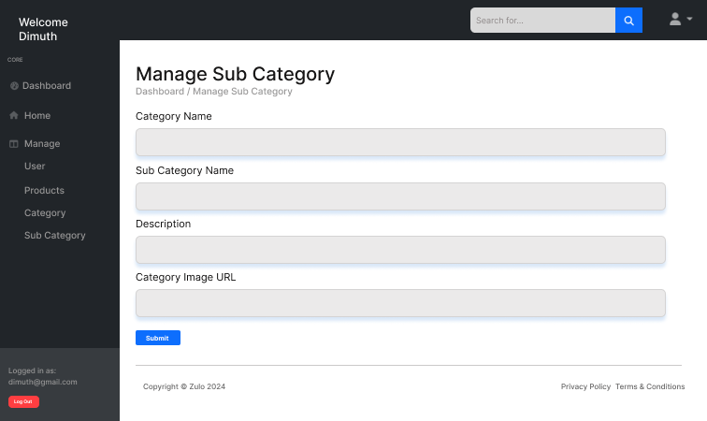

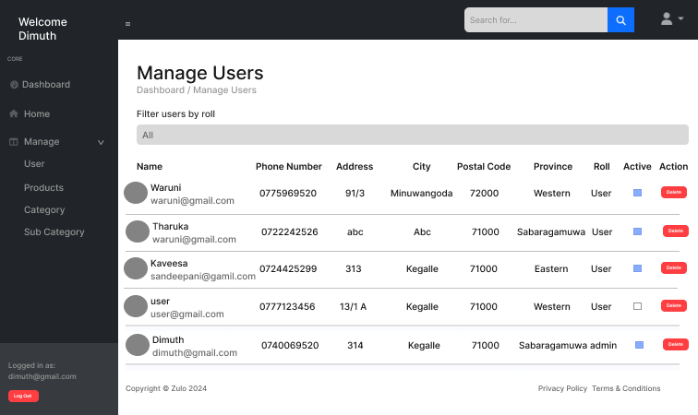

## **Individual Component Details**

**Project scope**

• Login and Registration

• Manage Products and Display Products

• Checkout

• User Account Handling and Admin Management

**Login and Registration**

C - Add a new user to the database when they register.

R - Verify user credentials during login.

all user details display in the admin dashboard.

U - Change the status field to mark the account as suspended.

Modify the user type for a specific user.

D - Remove a user account completely from the database.

**Manage Products and Display Products**

C - Insert new products into the database through the admin panel.

R - Display all products for the admin to manage.

U - Allow the admin to update product details.

D - Remove products that are no longer needed from the database.

**Checkout**

C - Add products to the cart when the user selects them.

R - Show all items in the cart for the user to review.

U - Change the quantity of items in the cart.

D - Remove products from the cart when the user deletes them.

**User Account Management and Wishlist**

C - Add an item to the user’s wishlist.

R - Display all the items in the user’s wishlist.

U - User account profile update.

D - Remove an item from the user’s wishlist.

# Conclusion

The **Zulo E-commerce website** has been successfully developed with features that enhance user experience and ensure robust functionality. Achievements include:

* A responsive and user-friendly design, utilizing **Bootstrap** for cross-device compatibility.
* Efficient handling of e-commerce operations such as product browsing, wishlist management, and order history tracking.
* Integration of **PHP** and **MySQL** for secure user authentication and data management.
* Implementation of lazy loading using **lazysizes** for optimized performance.
* Use of **Sharp** for efficient image processing and improved visuals.

**Challenges Faced and Solutions**

* **Challenge:** Optimizing page load times for a better user experience.  
  **Solution:** Implemented lazy loading with the **lazysizes** library, reducing initial load times for media-rich pages.
* **Challenge:** Ensuring compatibility across various devices and screen sizes.  
  **Solution:** Designed the layout using **Bootstrap**, which provided responsive templates and adaptive elements.
* **Challenge:** Managing large numbers of product images efficiently.  
  **Solution:** Integrated the **Sharp** library for image resizing and optimization.

**Future Improvements and Additional Features**

* **Integration of a payment gateway** to enable real-time online transactions securely.
* **Enhanced search functionality** with advanced filtering options for better navigation.
* **AI-driven product recommendations** to personalize the shopping experience.
* **Multi-language support** to cater to a global audience.
* **Admin dashboard** for efficient management of inventory, orders, and user activities.

## **References**

* **Bootstrap Official Documentation** - For responsive design and layout customization.  
  *Website*: <https://getbootstrap.com>
* **PHP Manual** - For backend development and session management.  
  *Website*: <https://www.php.net/manual>
* **MySQL Documentation** - For database setup and query handling.  
  *Website*: <https://dev.mysql.com/doc>
* **Sharp Library Guide** - For image processing and optimization.  
  *Website*: https://sharp.pixelplumbing.com
* **Lazysizes Library Documentation** - For lazy loading implementation.  
  *Website*: https://afarkas.github.io/lazysizes
* **W3Schools Tutorials** - For HTML, CSS, and JavaScript basics.  
  *Website*: <https://www.w3schools.com>
* **Font Awesome Icon Guide** - For adding icons to the user interface.  
  *Website*: <https://fontawesome.com>